Homework Report – Intelligent Hacker News Crawler
Part 1: Experiment Plan
Objective:
Develop an intelligent crawler for Hacker News that can:
- Accept natural language (topic) or a URL as input.
- Automatically find relevant articles based on the topic or fetch the page content from a URL.
- Clean the text (remove HTML, special characters, emails) and store it in databases (hn_raw.db and hn_cleaned.db).
- Display examples of the collected and cleaned data.
Methodology:
- The system is modularized for maintainability and clarity:
- crawler.py — page downloading and topic search.
- cleaner.py — text cleaning functions.
- db.py — SQLite database handling.
- agent.py — integrates crawl, clean, and save operations.
- inspector.py — view examples of the data.
- main.py — entry point for the intelligent agent.
- Asynchronous downloading using asyncio and aiohttp is employed for handling multiple URLs efficiently.
- Two modes of operation:
- Classic Pipeline: hn_crawler_pipeline.py
- Intelligent Agent: main.py (accepts topic or URL)

Part 2: Architecture (by Diagram)
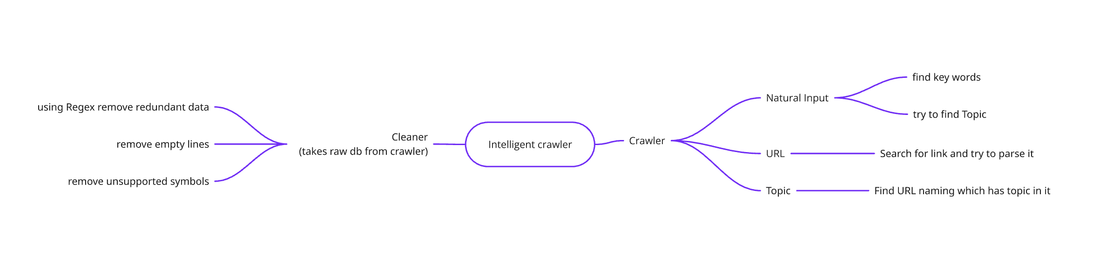
Part 3: Steps and Screenshots
Step 1: Run the Intelligent Agent

Prompt:
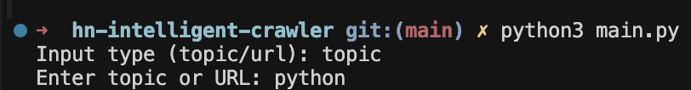
Response:
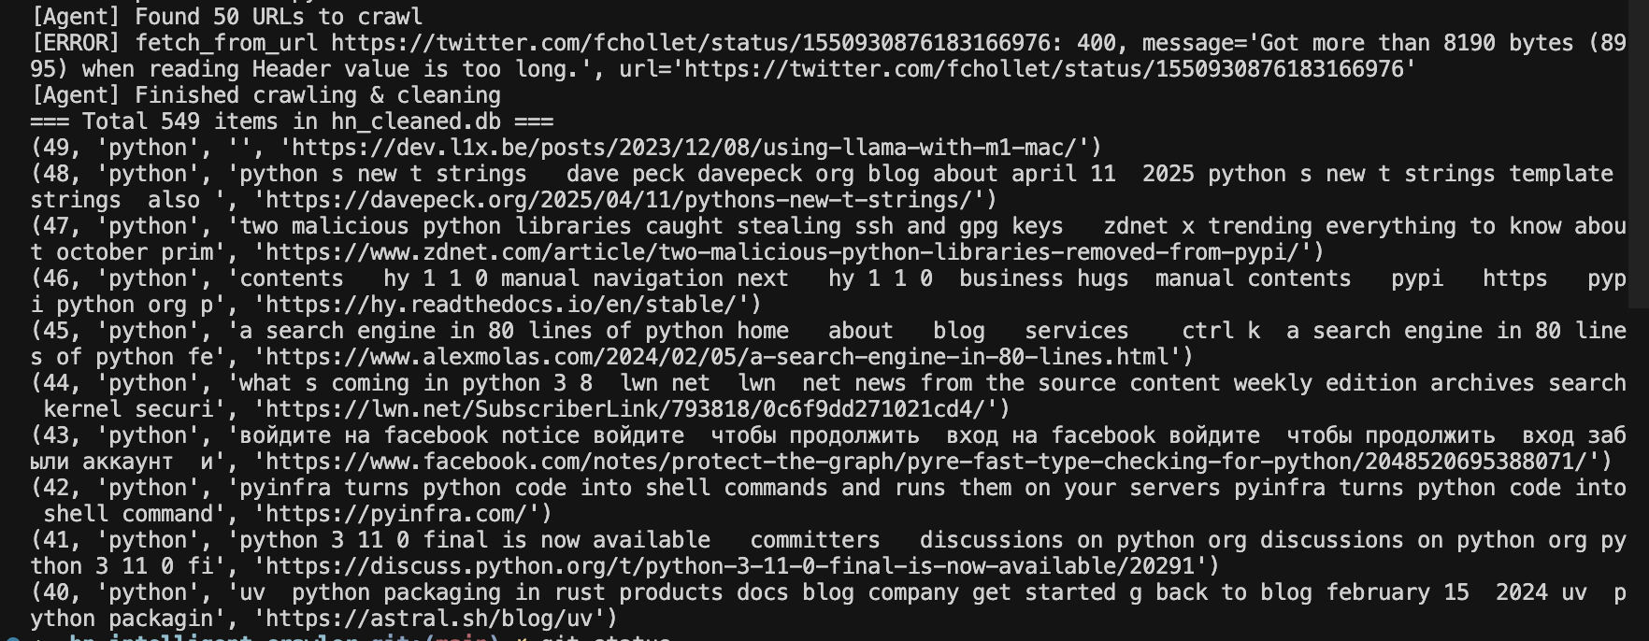

Step 2: Run the Classic Pipeline
Prompt: 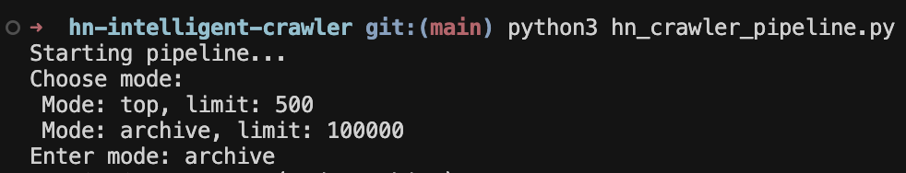
Response: 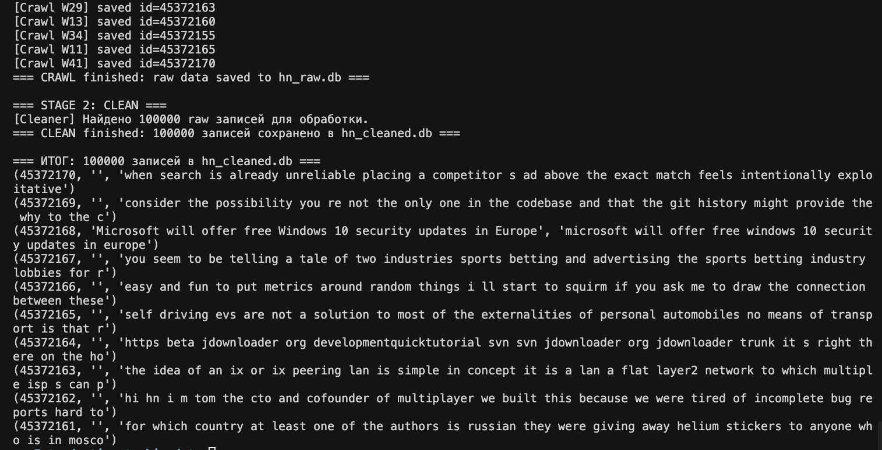
Step 3. Inspect Data
Prompt:
from inspector import print_examples
print_examples(n=10)
Response:
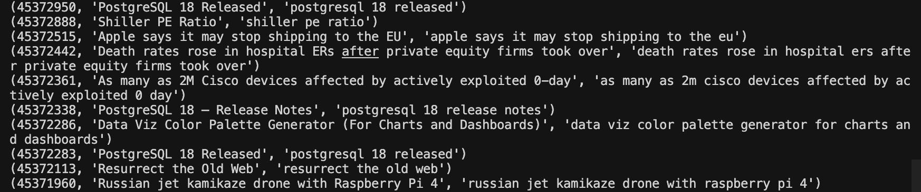
Final Result
- Raw data collected from Hacker News or URLs is stored in hn_raw.db.
- Cleaned data is stored in hn_cleaned.db.
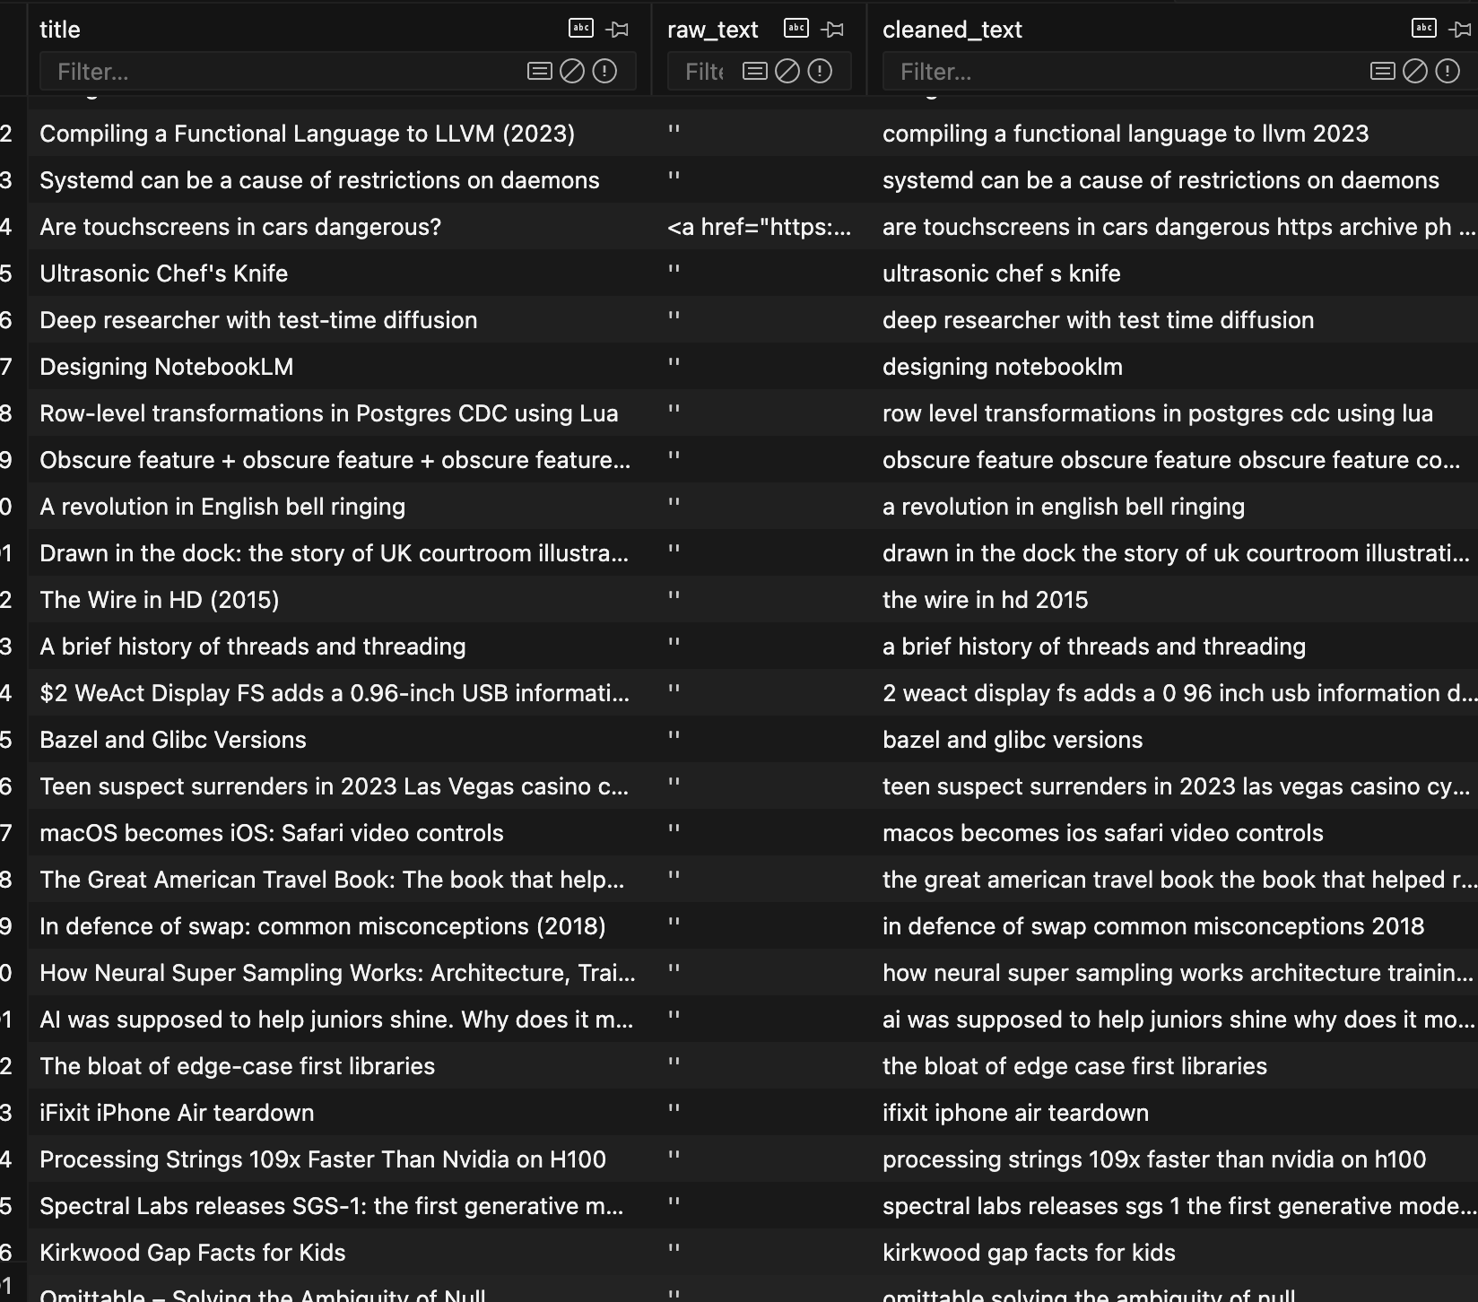
- The intelligent agent can fetch information by topic or URL, clean it, and display sample outputs.
- The classic pipeline works for batch crawling and cleaning top or archive stories.
Conclusion:
The system successfully demonstrates an intelligent crawler and cleaning agent with modular architecture, asynchronous processing, and dual operational modes.
There is a link to my project:
https://github.com/IMNJL/BigDataAnalysis/tree/main/hn-intelligent-crawler
- Scroll to the bottom to view some videos)

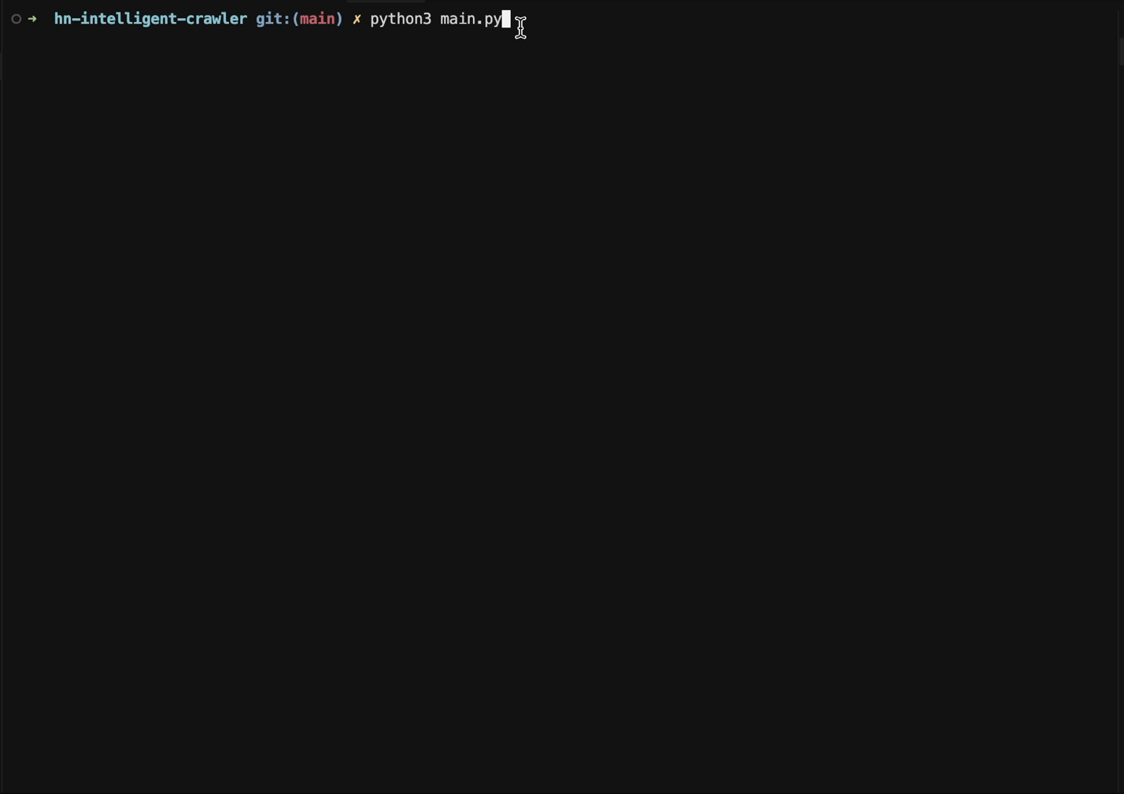
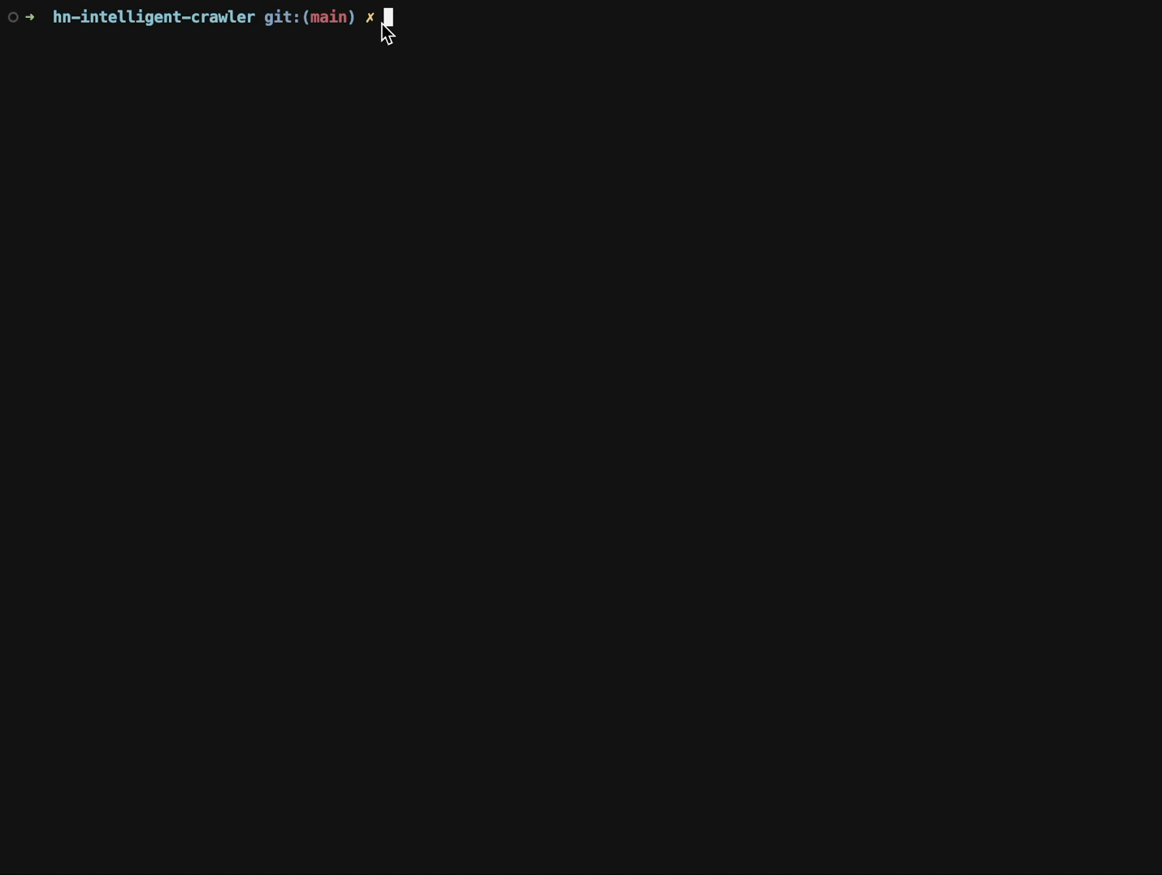
Apendix A. Video of using standart(not intellectual crawler)
Apendix B. Video of using Intellectual crawler

